**Guru Teg Bahadur Public Sr .Sec. School Noorpur (Bijnor)**

Holiday Homework (Class-I) Session 2015-16

**G.K./ M.Sc.**

1. Write the 5 foods names which we get from animals.

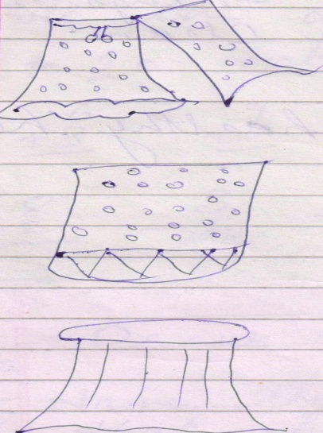2. Write the clothes names.

3. Write the 5 outdoor games names.

4. Draw the pictures of leaves. (Rose,Mango, Neem, Banana)

**Maths**

1. 1 to 50 counting.
2. 51 to 100counting.
3. 100 to 51 back counting.
4. 50 to 1 back counting.
5. 2 to 5 tables.
6. Write the 1 to 20 numbers in words.
7. Write the ordinal numbers 1 to 10.
8. 6 to 10 tables learning.
9. Add: 6 9 4 3 8 9 8 3

+ 3 + 3 + 4 + 8 + 2 + 5 + 8 +2

1. Sub: 8 3 5 8 4 8 3 5

- 2 - 1 - 5 - 3 - 1 - 8 - 1 - 4

**fgUnh**

1 +Loj fy[kksA 2 + O;atu fy[kksA 3 + fp= cukvks ¼vpdu] uy] fdrkc, eNyh] cVu] rkyk] xktj½

4 +fp= ns[kdj fy[kksA

5

5 + “kCnksa dks iwjks djksA 1 + jxn 2 + l d 3 + ?k 4 +ifg 5 + eNy

6 +v ls v% rd fy[kksA 7 + d ls K rd fy[kksA

8 + ek=k yxkvksA

1 + r y 2 + r d;k 3 + eNy 4 + x tj 5 + xVkj

9 + okD; iwjs djksA

1 + vk”kk iguA 2 + iou pykA

3 + jfo ctkA 4 +jghe ctkA

10 + Loj ds fp= cukvksA

**English**

1. A to Z capital letters.
2. a to z small letters.
3. Make two-two words with each letter A to Z. (As A for Apple, Ant)
4. Draw the pictures. (Bell, Pot, Bird, Apple, Mango)
5. Write picture names:
6. Myself:
7. The Cow (5 sentences)
8. 8 fruits names with pictures.
9. 8 vegetables names with pictures.
10. 8 colours names.

**EVS**

1. Write 5 sentences about yourself.
2. How many are these:

Eyes _______ Nose ________ Ears _________ Hands ___________

Legs _______ Fingers _______ Teeth _________ Tongue __________

1. Write 10 parts of body.
2. Draw a smiley face.
3. Name the parts of the body that help you to do the following:
4. Taste your favourite food _________ (b) Smell you favourite flower _________

(c) Watch your favourite cartoon ________ (d) Listen your favourite story __________

(e) Touch your favourite toy ___________

**Computer**

1. Fill in the blanks:
2. C ____mp __ t ___r (b) W ___s ___i ____g M____ ch___ne (c) T ____ r _____

(d) P ____ ct ___ r ___ (e) ___a____t (f) V ____r ____ (g) M ____s ___ c

(h) J ___ i ___e (i) F ____n

2. Write the names of 5 machines.

3. Write the names of two machines which run on fuel.

4. Write the names of two machines which run on man power.

5. Name two machines which run of electricity.

6. Draw the pictures of monitor and printer.

7. Write the parts of computer.

] ]